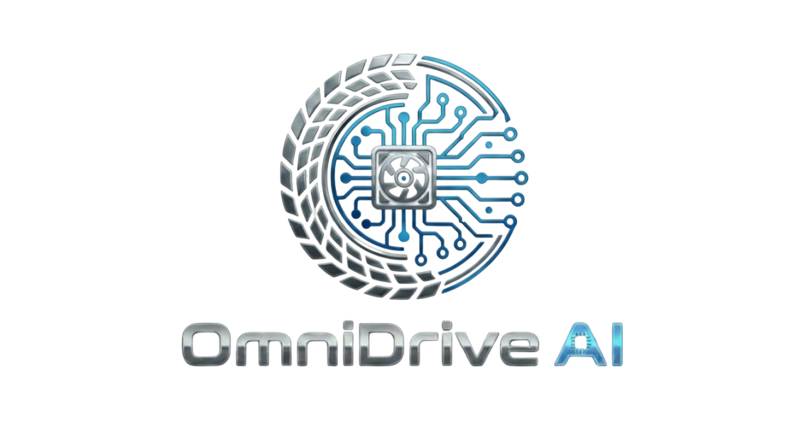

Defense Proposal

FYP Team
Ammar Akbar 22F-3102
Sameer Khan 22F-3162
Murtaza Mehdi 22F-3101
Supervised by
Ms. Juhinah Batool Asif

Department of Artificial Intelligence & Data Science
National University of Computer and Emerging Science
Chiniot, Pakistan
2026
Anti-Plagiarism Declaration

This is to declare that the above publication produced under the:
Title: OmniDrive AI
is the sole contribution of the author(s) and no part hereof has been reproduced on as it is basis (cut and paste) which can be considered as Plagiarism. All referenced parts have been used to argue the idea and have been cited properly. I/We will be responsible and liable for any consequence if violation of this declaration is determined.
Date: ______________
Student 1
Name: Ammar Akbar

Signature:___________________
Student 2
Name: Sameer Khan

Signature:___________________
Student 3
Name:Murtaza Mehdi

Signature:___________________

Abstract
OmniDrive AI is a unified digital ecosystem designed to modernize the automotive enthusiast experience by bridging traditional offline auto markets with intelligent technologies. The platform provides a multifunctional mobile solution that enables users to identify unknown vehicle parts using AI-based visual recognition, purchase them from a curated network of local vendors across multiple cities, and receive doorstep delivery through a hyper-local rider-based logistics system. At its core, OmniDrive AI features an intelligent Build Assistant that generates personalized, budget-optimized modification plans and build sheets based on user-defined performance goals. The system also includes a GPS-based performance tracker for accurately measuring 0–100 km/h and quarter-mile times as a cost-effective alternative to specialized hardware, along with a community-driven Knowledge Hub and an AutoEvent Connect module that uses recommendation-based filtering to streamline auto shows invitations through single-click notifications for community leaders.
Table of Contents
1. Introduction 1
1.1. Problem Statement 1
1.2. Objectives 2
1.3. Motivation 2
1.4. Overview 2
2. Functionality 3
2.1. AI Visual Part Hunter & Identification 3
2.2. Live Vendor Inventory Management 3
2.3. Hyper-Local Rider Dispatch & Delivery 4
2.4. AI Expert Build Assistant 4
2.5. GPS Performance Analytics 4
2.6. Automotive Knowledge Hub 4
2.7. AutoEvent Connect 5
3. Tools and Technologies 5
4. Required hardware and Software resources 6
4.1. Hardware 6
4.2. Software 7
5. High Level Diagram 8
6. Timeline 8
7. Work break down structure 9
8. References 9

Introduction:
OmniDrive AI is inspired by the real world journey of Pakistani car enthusiasts, turning the frustration of a broken part or a confusing modification into a seamless digital experience. By putting a digital assistant in your pocket, the platform allows you to identify any unknown component with a simple photo, instantly locating it in a local vendor’s catalog and dispatching a rider for immediate delivery. The experience continues through an AI-powered assistant that acts as a personal consultant to design budget-friendly build sheets, paired with a high-precision GPS tracker to help you validate your performance gains without needing expensive external hardware. Ultimately, OmniDrive AI unites the car community in a single home, where you can exchange advice in a dedicated knowledge hub or receive a one-click invitation to the next auto show through a streamlined event portal.

Problem Statement:
Automotive enthusiasts in Pakistan face four major hurdles:
- Identification Gap: Users frequently encounter high-performance or car parts in local markets but lack the technical expertise to identify them by name, leading to incorrect purchases and mechanical failures.
- Market Fragmentation: Traditional offline vendors in hubs like Lahore and Peshawar operate without digital inventory systems, forcing customers to physically scout multiple shops to verify part availability or pricing.
- The Invitation Bottleneck for Organizers: Organizing a large-scale auto show currently requires teams to manually contact dozens of individual car community leads via fragmented social media groups. This manual outreach is inefficient, lacks professional tracking, and often results in missed opportunities for high-profile car teams to showcase their builds.
- Cost Barriers to Performance: Professional grade performance-tracking hardware (e.g., Draggy) is prohibitively expensive for the local enthusiast market, creating a data gap for users trying to validate their car's tuning progress.

Objectives
- Automated Part Recognition: To implement a YOLO-based Computer Vision model that allows users to instantly identify vehicle components via a smartphone camera.
- Digital Market Integration: To create a Live Inventory Management Portal for offline vendors, allowing them to synchronize their physical stock with a searchable digital catalog.
- Hyper-Local Logistics: To establish a dedicated Rider Dispatch System that handles delivery of parts directly from traditional markets to the end consumer.
- Enterprise-Level Event Coordination: To develop a Centralized Auto-event Portal that allows university and brand organizers to send professional, one-click invitations to verified community leaders, transforming a weeks-long manual task into a seamless digital process.
- Precision Performance Monitoring: To provide a cost-free, high-accuracy GPS Performance Timer that utilizes smartphone sensor fusion to record 0–100 km/h and quarter-mile metrics.

Motivation
The automotive culture in Pakistan is rapidly evolving, yet the tools supporting it remain primitive. We found that even the most dedicated enthusiasts struggle with a lack of centralized guidance and fragmented supply chains. The primary motivation behind OmniDrive AI is to build a modern network that facilitates communication between the "offline" market and the "online" enthusiast. By digitizing inventory and automating event management, we aim to provide a blueprint for the industry to grow professionally while giving students and DIY owners the tools to pursue their passion with data-driven accuracy.

Overview
OmniDrive AI is a mobile-first ecosystem designed to serve as the primary digital interface for the Pakistani automotive community, specifically connecting enthusiasts, offline vendors, and event organizers within a single unified platform. While generic e-commerce and social networking applications exist, OmniDrive AI is unique in its focus on the specialized needs of the car guy demographic providing high-precision performance analytics, verified local market access, and a centralized hub for professional event coordination. By integrating computer vision and sensor-fusion technology, the system ensures that every phase of a vehicle's lifecycle—from part identification and procurement to performance validation and exhibition—is streamlined, verified, and community-driven.

Functionality
OmniDrive AI is a multi-platform ecosystem, comprising a high-performance Android application for enthusiasts and a Web-based dashboard for vendors and event organizers. This dual-platform approach creates a seamless link between the offline automotive markets of Lahore and Peshawar and the digital enthusiast community. By leveraging Computer Vision and Sensor Fusion, the system provides a data-driven blueprint for car builds and event coordination, replacing the currently fragmented and unverified methods of automotive tuning and part procurement.
The project would’ve the following features:

AI Visual Part Hunter & Identification
- Users can capture images of unidentified or independent vehicle components via the mobile app.
- The system utilizes a pre-trained YOLO or EfficientNet model to instantly identify the part name and technical specifications.
- This feature simplifies the procurement process for novice DIY owners who may not know the technical terminology of the parts they require.

Live Vendor Inventory Management
- A dedicated portal allows offline vendors to maintain a digital catalog of their stock.
- Vendors have the authority to add, update, or remove items in real-time to reflect physical sales and new arrivals.
- The system synchronizes this data with the search results of users, ensuring that part availability is always accurate.

Hyper-Local Rider Dispatch & Delivery
- The platform integrates a city-specific logistics layer for delivery.
- Once a user places an order through the vendor catalog, a nearby rider receives a notification to pick up the part.
- This creates a professional supply chain from traditional markets like Bilal Ganj directly to the user’s doorstep.

AI Expert Build Assistant
- A rule-based Expert System acts as a virtual consultant for vehicle modifications.
- Users input their specific budget and performance goals (e.g., Drag or Track), and the system generates a validated "Build Sheet".
- The system cross-references part compatibility to ensure all suggested modifications are mechanically sound.

GPS Performance Analytics (Drag Meter)
- The application replaces expensive specialized hardware (e.g., Draggy) using the smartphone's internal sensors.
- By utilizing GPS and Accelerometer sensor fusion, the app records precise timings for 0–100 km/h and Quarter-Mile runs.
- These verified performance logs can be shared directly with the community to validate tuning progress.

Automotive Knowledge Hub (Forums)
- A centralized community space allows users to discuss trending automotive topics and project logs.
- Experienced users can provide DIY advice and help troubleshoot mechanical issues for the community.
- The hub serves as a social verification platform for performance results recorded via the GPS Drag Meter.

AutoEvent Connect (Invitation Portal)
- A professional interface for university and brand organizers to manage large-scale auto shows.
- Organizers can filter car communities by location, team size, or car model and send mass invitations with a single click.
- This module automates the currently manual process of contacting dozens of community leaders individually, ensuring efficient event coordination.

Tools and Technologies
The development of OmniDrive AI utilizes a modern, robust tech stack to ensure high performance, scalability, and seamless hardware integration.
Technology | Tool | Description
Mobile Development | Flutter (Dart) | A cross-platform framework used to build high-performance Android and iOS applications with a single codebase, ensuring smooth access to hardware sensors like GPS and Accelerometer. | 
Backend Framework | FastAPI (Python) | A high-speed asynchronous web framework used to manage the AI-powered backend, vendor catalog logic, and rider dispatch systems. | 
Computer Vision | YOLO / EfficientNet | Deep learning models optimized for real-time object detection and image classification, specifically trained for identifying automotive components | 
Backend & Database | Supabase | A unified backend-as-a-service providing a managed PostgreSQL database, Real-time sync, and Secure Auth in one ecosystem. | 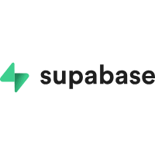
Development Environments | VS Code / Android Studio | The primary IDEs used for writing backend logic and designing the mobile UI. | 
UML Design Tools | Microsoft Visio / Draw.io | The system architecture will be planned and documented using Visio or Draw.io to create UML diagrams. | 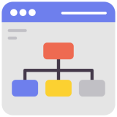

Required hardware and Software resources

Hardware Resources

Following development PC is required to develop this project
Hardware Component | Specifications
Processor | Intel Core i5 or i7 (10th Gen or higher) or equivalent AMD Ryzen.
Memory (RAM) | 16 GB RAM (Required for running multiple instances of Android Emulators and the AI backend concurrently).
Storage | 512 GB SSD (For fast compilation and large datasets storage).
Graphics | NVIDIA GPU with 4GB+ VRAM (Recommended for training the Computer Vision models locally).
Mobile Device | Physical Android Device with high-accuracy GPS and Accelerometer for testing.

Software

Following softwares are required for the development of this project
Software | Purpose
Android Studio / VS Code | Core application and backend development
Figma / Adobe XD | UI/UX Prototyping and high-fidelity screen design.
PyTorch/TensorFlow | LLM Model Training
FastAPI / Flask (Python) | Backend API & Model Serving
PostgreSQL | Database Management
Draw.io / Microsoft Visio | UML designing, system architecture, and High-Level Diagramming.
Docker | Containerization for consistent backend deployment.

High Level Diagram

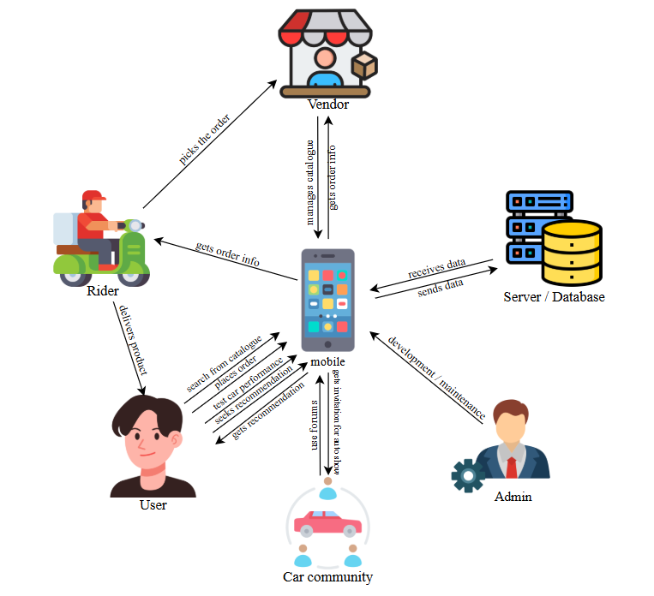

Timeline
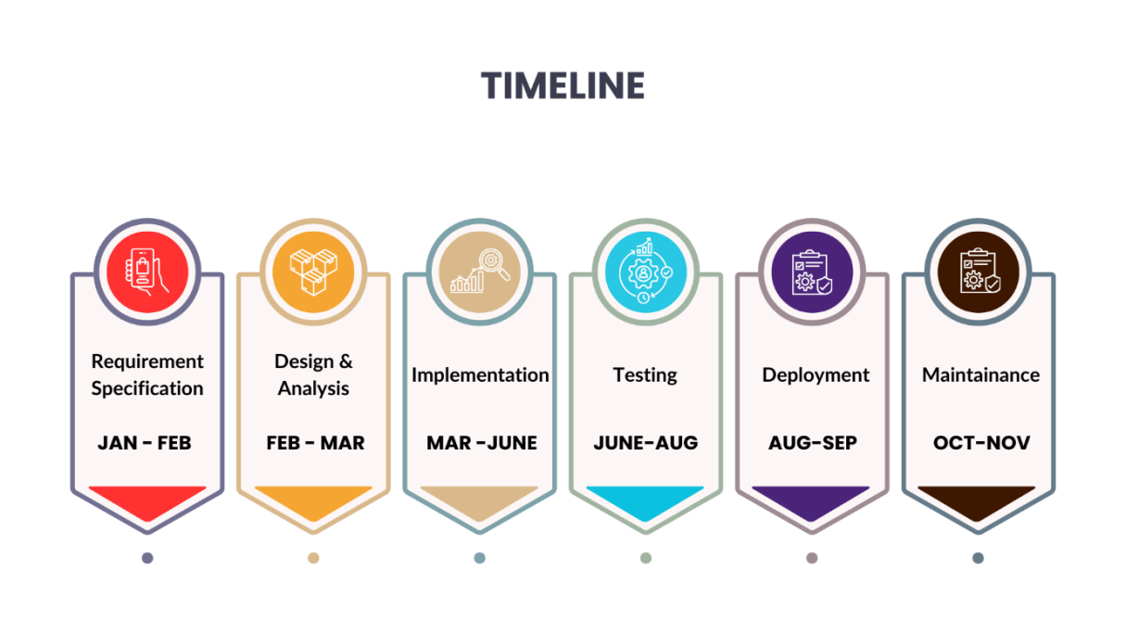

Work break down structure
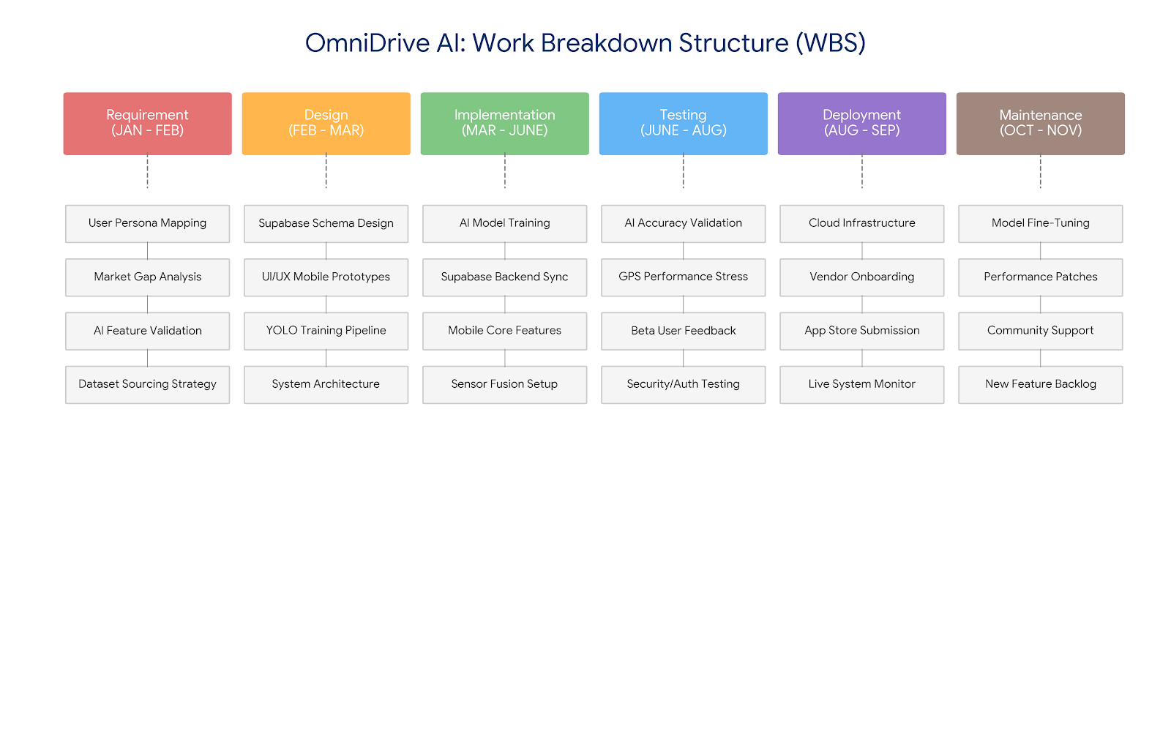

References
- draw.io
- supabse.com
- flutter.dev
- https://docs.ultralytics.com/

